# TAKE HOME TASK

**Raahim**

**24k-0543**

#include <iostream>

#include <string>

using namespace std;

const int n_cities = 4;

const int n_days = 7;

void get_aqi(int aqi[n_cities][n_days]) {

cout << "Enter AQI values for " << n_cities << " cities over " << n_days << " days:\n";

for (int i = 0; i < n_cities; i++) {

cout << "City " << (i + 1) << ":\n";

for (int j = 0; j < n_days; j++) {

cout << "Day " << (j + 1) << ": ";

cin >> aqi[i][j];

}

}

}

void avgaqi(int aqi[n_cities][n_days]) {

float avg[n_cities] = {0};

int worst_idx = 0;

for (int i = 0; i < n_cities; i++) {

int total = 0;

for (int j = 0; j < n_days; j++) {

total += aqi[i][j];

}

avg[i] = total / static_cast<float>(n_days);

cout << "Avg AQI for City " << (i + 1) << ": " << avg[i] << endl;

if (avg[i] > avg[worst_idx]) {

worst_idx = i;

}

}

cout << "City with worst air quality: City "

<< (worst_idx + 1) << " with average AQI of "

<< avg[worst_idx] << endl;

}

void crit_days(int aqi[n_cities][n_days]) {

cout << "Critical Pollution Days (AQI > 150):\n";

for (int i = 0; i < n_cities; i++) {

cout << "City " << (i + 1) << ": ";

bool has_crit = false;

for (int j = 0; j < n_days; j++) {

if (aqi[i][j] > 150) {

cout << "Day " << (j + 1) << " ";

has_crit = true;

}

}

if (!has_crit) {

cout << "None";

}

cout << endl;

}

}

void report(int aqi[n_cities][n_days]) {

cout << "\n*** AQI Report ***\n";

for (int i = 0; i < n_cities; i++) {

float weekly_avg = 0;

int max_aqi = aqi[i][0];

int min_aqi = aqi[i][0];

for (int j = 0; j < n_days; j++) {

weekly_avg += aqi[i][j];

if (aqi[i][j] > max_aqi) max_aqi = aqi[i][j];

if (aqi[i][j] < min_aqi) min_aqi = aqi[i][j];

}

weekly_avg /= n_days;

cout << "City " << (i + 1) << ":\n";

cout << " Weekly Avg AQI: " << weekly_avg << endl;

cout << " Highest AQI: " << max_aqi << endl;

cout << " Lowest AQI: " << min_aqi << endl;

}

cout << "\n*** Critical Pollution Days Summary ***\n";

crit_days(aqi);

}

void display_data(int aqi[n_cities][n_days]) {

cout << "AQI Visualization:\n";

for (int i = 0; i < n_cities; i++) {

cout << "City " << (i + 1) << ": ";

for (int j = 0; j < n_days; j++) {

int star_count = aqi[i][j] / 50;

for (int k = 0; k < star_count; k++) {

cout << "#"; // Using '#' instead of '*'

}

cout << " ";

}

cout << endl;

}

}

int main() {

int aqi[n_cities][n_days];

get_aqi(aqi);

avgaqi(aqi);

crit_days(aqi);

display_data(aqi);

report(aqi);

return 0;

}

**OUTPUT**

**TASK 1:**

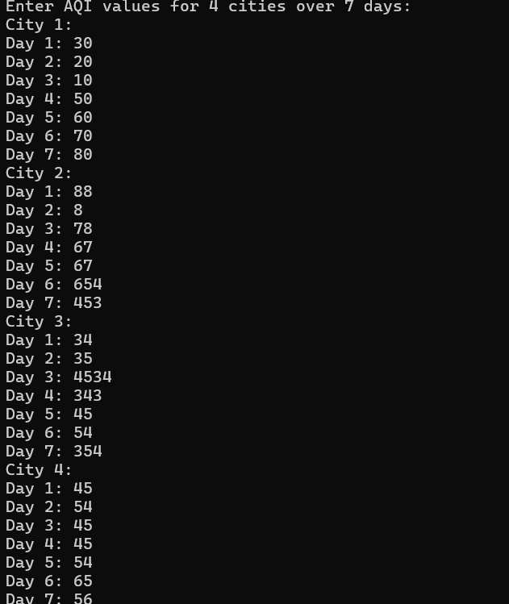

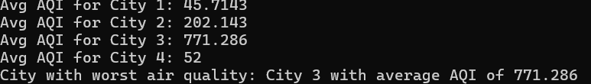

TASK 2:  
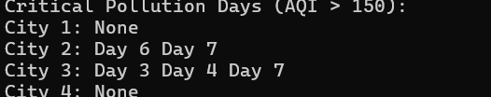

TASK 3;



TASK 4:  
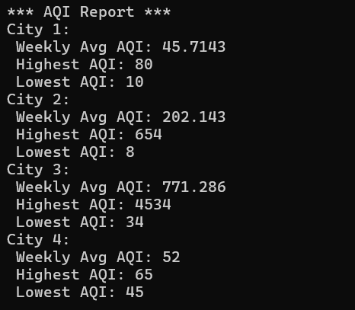

TASK 5:  


